CKAPP03 - CKAPP03 - Display Sales Order Items to be Costed

Functionality
You can call up this report to obtain a quick overview of the sales order items to be costed. Flat product materials are costed on the sales order. The materials are costed and marked when the sales order is saved. It is possible that a sales order cost estimate, may be saved with error due to routings or BOM changes. In order to monitor these sales orders with incorrect cost estimates you need to run this report. The report lists down the sales order in the order of delivery date. The report has 2 columns Status SD and Costing status. In case of incorrect cost estimate the Status SD column will show COST and the costing status as blank.

Scenario
Run this report periodically or daily to find the sales order to be costed for configured material.

Requirement
Sales order created for configured material

Menu Path | Accounting → Controlling → Product Cost Controlling → Cost Object Controlling → Product Cost by Sales Order → Information System → Reports for Product Cost by Sales Order → Object List → CKAPP03 – Display Sales order Items to be Costed
Transaction Code | CKAPP03

1. Double Click CKAPP03 - Display Sales Order Items to be Costed

Display Sales Order Items to be Costed

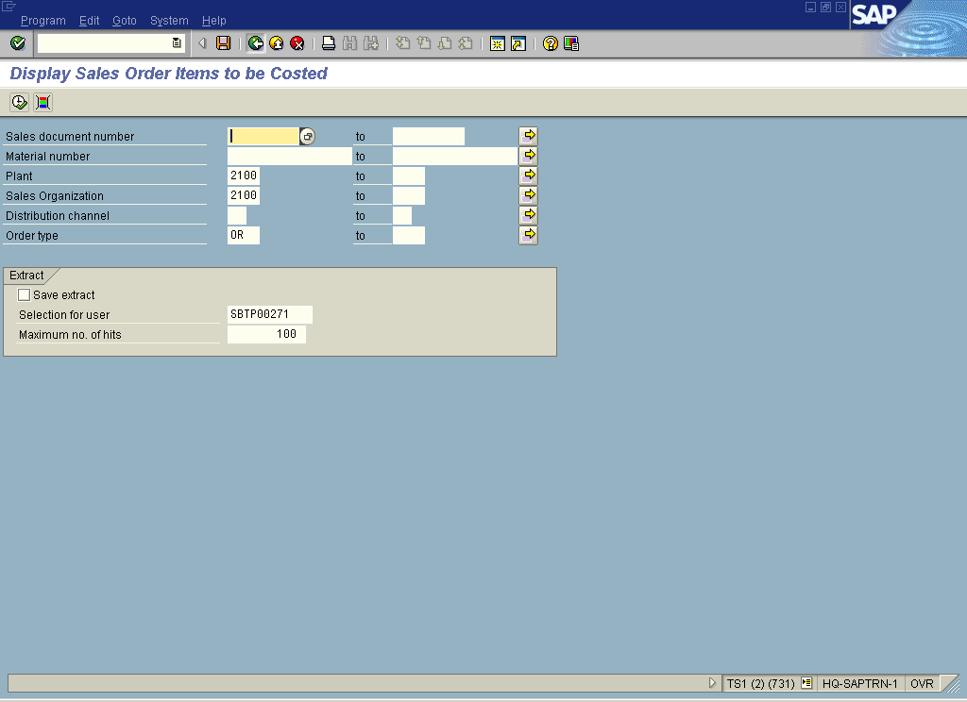

2. Update the following fields:

Field Name | Description | Values
Plant | Code identifying the operational unit of the company where the material is manufactured and stored | Enter value in Plant.  Example: 2100
Sales Organization | Description of the Sales Organization. | Enter value in Sales Organization.  Example: 2100
Order type | Description of the Order type. | Enter value in Order type.  Example: OR

3. Click <checkbox> Save extract .

4. Click Execute
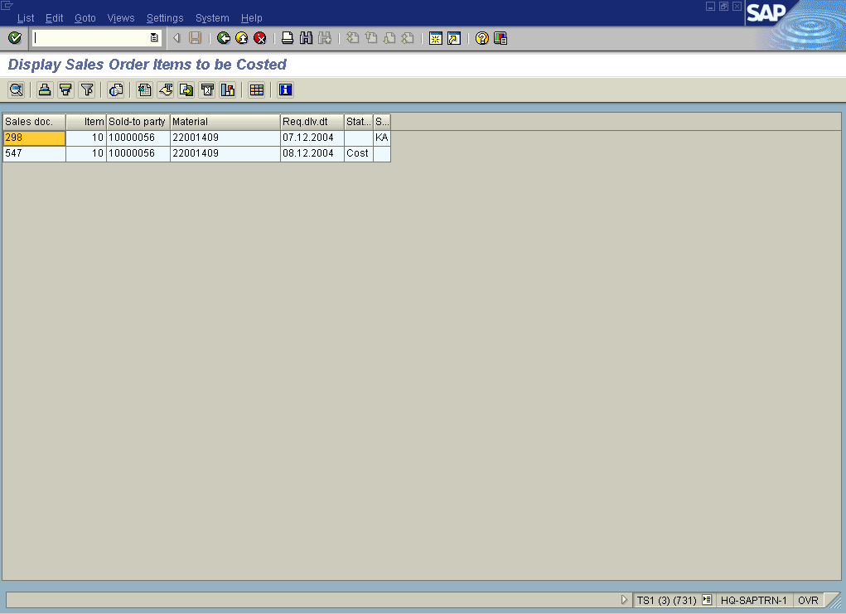
5. Click Back

6. Click Back

